激光跟踪仪的测量管理标准
Management Instruction for Laser Tracker Measurement

- Scope

This management instruction specifies the measurement requirements of laser tracker.
This management instruction is applicable to commercial aircraft production.
This management instruction is developed per the requirement of GLC14080302.

- Reference Documents

D6-81690 Three-Dimensional Measurement System Parameters and Guidelines
GLC231007 Management Procedure for Technical Document
GLC231008 Management Procedure for Quality Records
GLB14080302-04 Management Instruction for Inspection Dataset
GLB260901-04 Usage and Management Instruction of Laser Tracker

3 Form

3.1 Prescribed Form
FM1408-27 Survey Information Statistics in a Station for Laser Tracker
3.2 Referenced Form
None

4 Terms and Definitions

4.1 Special Adaptor and Reflector
When drawing or technical documents did not specify types of adaptor and reflector, or they did specify types but adaptor or reflector actually used was not the specified one during measurement, the data with offset gained from using these adaptors or reflector is required to input to CATIA for analyzing, then the final result of data can be used.

5 Regulations

5.1 Except for periodical tooling inspection, production unit shall develop the measuring plan according to the valid drawings, model, and technical documents, including but not limited to the following contents. For the measurement plan of periodical tooling inspection, see technical requirements of periodical tooling inspection/ periodical tooling inspection plan.

5.1.1 The measurement plan shall specify the tooling used for parts measurement. If the measurement plan is for multiple parts, it is necessary to specify the number of each tooling corresponding to different parts(if duplicated tooling will be used, tooling unit number need to specified); if tooling is not used in the measurement process, it is necessary to specify the way of placing parts and the method of clamping (stabilization).

5.1.2 The measurement plan shall describe the model number (for Boeing program, extension should be described) and edition of the measured product / the drawing number and edition of the tooling.

5.1.3 The measurement plan shall specify all features to be measured and corresponding datum. When words are not enough for description, features should be applied for identification. If measurement device will not be used to analyze measured data, analysis methods shall be clearly specified.

5.1.4 Production unit develops measurement plan per GLC231007 or specified format of production unit, number and revision shall be described for measurement plan.

5.1.5 The measurement plan shall be put into use after being approved.
5.2 Product / Tooling Measurement

5.2.1 The laser tracker used must be within the validity period of verification.

5.2.2 The measurement unit shall carry out the measurement according to the measurement plan.

5.2.3 The data and report shall be transferred to the inspection personnel for confirmation.
5.3 Measurement Data Analysis
5.3.1 It is recommended to use the laser tracker software to analyze the data and issue a report.
5.3.2 If CATIA software is used for analysis, the following information shall be included in the analysis results model:
(1) The version of the analysis results MBD (expressed with capital letters a-y, where I, Q, O, s, x, Z shall not be used. When a ~ y is not enough, it can be used in the order of AA ~ Ay, Ba ~ By...).
(2) Date of analysis.
(3) Description of authorized digital model source (including model number, version and extension name).
(4) Name of analyst.
(5) The purpose of the analysis result model is explained.
5.4 Key Measurement Steps
5.4.1 The operator shall complete the following key steps.
5.4.2 Measurement Preparation
(1) The measuring area should be protected or marked clearly to avoid the instrument or measuring part moving due to external force.
(2) Select adapter and reflector according to valid drawings or technical documents. When using special reflectors and adapters, the offset shall be recorded in FM1404-71. Flat mirror reflectors shall not be used in Boeing programs.
(3) The weather station is used to compensate the instrument.
5.4.3 Laser tracker field check should be performed before measurement for Boeing program, the requirements are as follows. The requirement of parameter setting and compensation after field check see D6-81690.
(1) The two face check should be performed before measurement for each station, one point shall be measured separately at level and plumb direction on the object being measured. The points shall enclose features to be measured, the tolerance is ±0.003°。 For using “Tracker Pilot” software to perform field check, the tolerance is ±0.003inch.
(2) ADM check shall be performed every 30 days with tolerance of ± 0.002inch. If laser tracker has been not used for production/tooling of Boeing program in 30 days, ADM check will be performed on before measuring production/tooling of Boeing program.
(3) IFM check shall be performed every 30 days with tolerance of ±0.0005inch. If laser tracker has been not used for production/tooling of Boeing program in 30 days, ADM check will be performed on before measuring production/tooling of Boeing program. If there is no "birdbath" on laser tracker, IFM check shall not be used.
(4) When a reflector drops or bumps, reflector check shall be performed. The tolerance of vertical and horizontal angle is 0.02°, the tolerance of distance is 0.001 inch.
5.4.4 Establishment of Coordinate System and Proportional Compensation
(1) Establish coordinate system according to valid drawings, models and technical documents.
(2) At least three datum points are needed to establish coordinate system by best fit transformation.
(3) When there are 7 or more qualified datum points (no reference value) to complete the best fitting, select the "automatic generation of scale" function to complete the proportion compensation when establishing the coordinate system. For other cases, the temperature of the measured parts is detected. For multi-layer tooling, the temperature of each layer is measured and the average value is taken. Then the material of the measuring part is selected in the measuring software, the temperature of the measuring part is imported, and the proportional coefficient is applied to compensate the measuring part.
(4) Data management in the measurement software should be pay attention to when performing measurement, keep the data structure legible and understandable. Create appropriate layered files to divide different measurement areas or features, which is convenience for afterward analyzing, evaluating and searching for measurement results.
(5)The tolerance of the best fit transformation shall be implemented according to the valid drawings or technical documents. If there is no requirement in the valid drawings or technical documents, the tolerance can be seen in GLB260901-04.
(6) In the case of using common points to establish datum coordinate system, at least 7 qualified common points are needed. Tolerance of common points is shown in GLB260901-04.
(7) The envelope formed by the coordinate points of the best fit transformation should contain the measuring piece.
(8) Except for special requirements, the tolerance of the best fit transformation is related to the X, Y and Z values of the coordinate points respectively, not to the total deviation (vector value).
5.4.5 After establishing the coordinate system, the temperature change of the measuring part shall be recorded and monitored. If the temperature change of the measuring part exceeds ±2.2℃. It is necessary to carry out scale compensation again and establish coordinate system. For multi-layer tooling, the temperature of each layer needs to be monitored.
5.4.6 Inspection of Measuring System
(1) Measure at least 2 drift points, if the drift point measurement result exceeds ± 0.003inch, it is considered that the measurement system is unqualified. If there is no fixed point on the measuring piece, it is necessary to build a fixed point on the measuring piece to complete the drift point measurement.
(2) Measure the value and temperature of the scale. If the temperature of the scale exceeds the temperature of the measuring piece ±0.56 ℃, or the measured value of the scale exceeds the theoretical value of the certified scale ±0.003inch, all of which are regarded as unqualified measurement system.
(3) After the establishment of coordinate system and data acquisition, the scale and drift point are measured once.
(4) When the measurement system is unqualified, the measurement data of the station is invalid and needs to be measured again.
5.4.7 Data Acquisition
(1) Measure the required characteristics. The naming of measurement characteristics shall be numbered according to the drawings and technical documents.
(2) When measuring the profile, at least 3 points should be measured on the profile, the measuring points should be evenly distributed, and the distance between adjacent points should not be greater than 150 mm, and more points should be taken at the increased curvature of the profile.
5.5 Measurement Report
5.5.1 The cover of measurement report should include the information as followed:
(1) Product digital model number and model edition (when measuring products, for Boeing program, the digital model number shall include the extension) .
(2) Tooling drawing number and tooling edition (when measuring tooling).
(3) Tooling digital model number and model edition (when measuring tooling for Boeing program, the digital model number shall include the extension) .
(4) Tooling part number (when measuring a tooling part).
(5) Product / tooling name (when measuring and copying tooling, the tooling name should include the number of sets information).
(6) The sortie / batch number / quality number of the product.
(7) Tooling work number(When there is no tooling work number, the number of measurement plan shall be used).
(8) Operator.
(9) Inspector.
(10) Datum tolerance.
5.5.2 Datum Report
5.5.2.1 When datum is set by datum point transformation, relation fitting or “quick align to CAD”, datum report needs to be presented for each station. “BEST-FIT” shall be used to present report for datum transformation, “relation of point to object” function shall be used to present report for relation fitting and “quick align to CAD”.
5.5.2.2 Datum report is not needed when coordinates system is set by axis alignment, but datum needs to be described in measurement report.
5.5.3 The measurement result report is output by the software used for data analysis.
5.5.3.1 Measurement Result Report which Adopt Data Analyzed by Laser Tracker Software
(1) Measurement report needs to be present for each station. The characteristics of the measured tooling / product are described in the report. For example: "measure the milling groove of tooling NCMF187W3300-302".
(2) Measurement illustration. Describe drawing of measured tooling/product, distribution of measurement point and results of several measurement points (if there is any point out of tolerance, it needs to be displayed). See fig 1 for example.
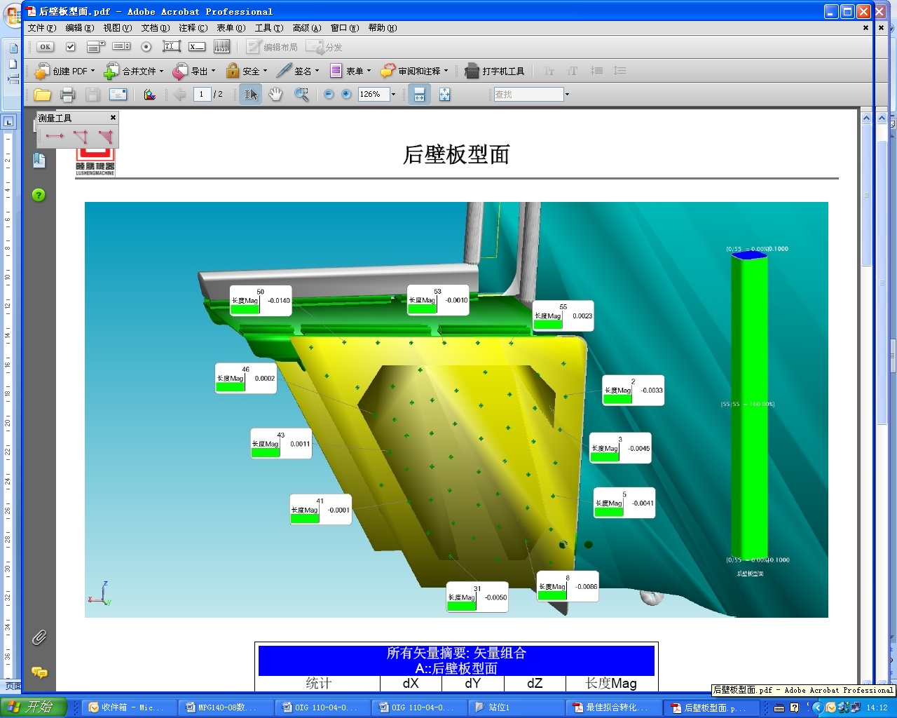
Fig 1 Example of Measurement Report Illustration
(3) Measurement results summarized form. It is summarized information for results of measurement points, including but not limited to tolerance, quantity of points that within and out of tolerance. See fig 2 for example.
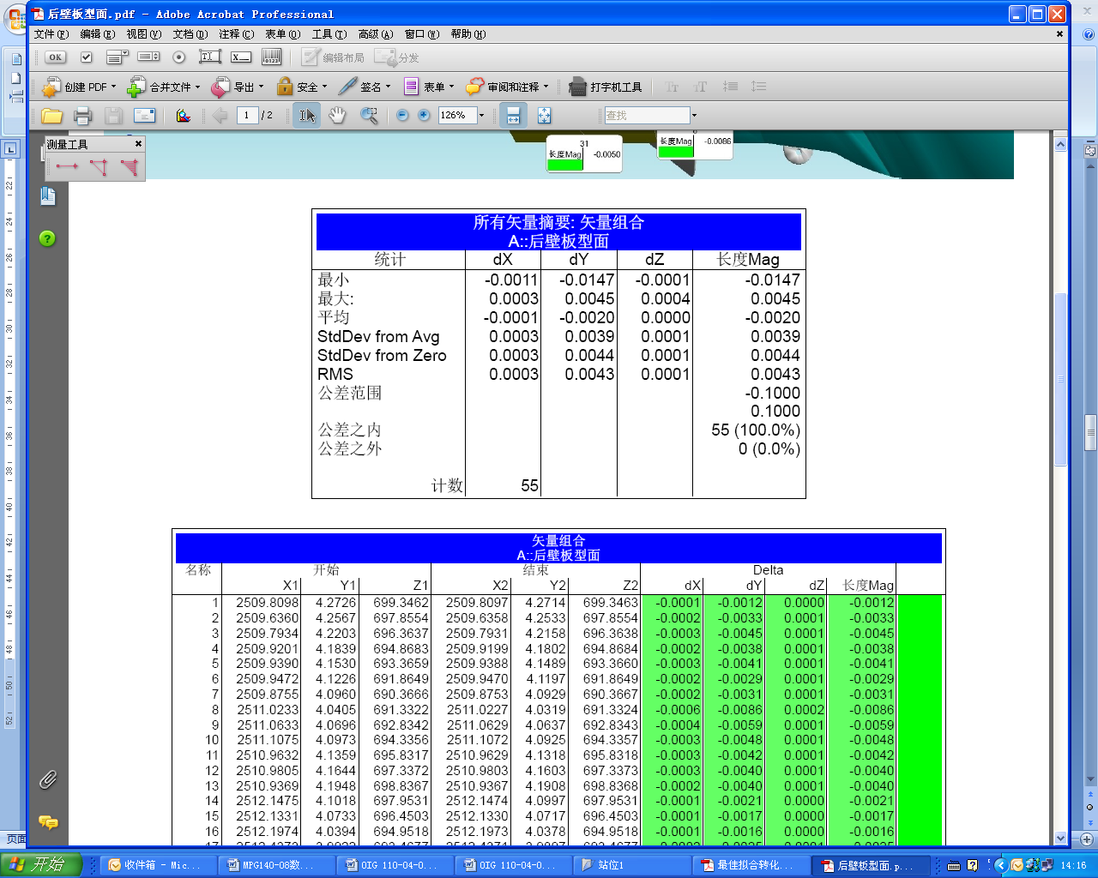
Fig 2 Example of Measurement Results Summarized Form
(4) Specific results of measured point. Including name of measurement point, theoretical coordinate values, actual measured coordinate values, the individual deviations of X, Y,Z values and the comprehensive deviation.
(5) If tooling ball points or OTP are measured, only item (3) and (4) of this chapter need to be included in the measurement report.
5.5.3.2 Measurement Result Report which Adopt Data Analyzed by CATIA
(1) The diagram of analysis result
(2) Description of analysis results, including: description of measuring parts, tolerance, description of whether the analysis results are qualified, with signature / seal and date of the analyst.
(3) For Boeing program, in addition to (1) and (2) of this section, it is also necessary to attach the corresponding authorized dataset information used to analyze the data, the measured coordinate value and deviation of the measurement point. When there are many measurement points, it is necessary to generate a line chart of the deviation of the measurement point to indicate the deviation status of the measurement data.
5.5.3.3 The number of measurement characteristic in report shall be named per drawings and technical documents.
5.5.3.4 When the customer has special requirements for the report format, it shall be implemented according to the customer's requirements.
5.5.4 Scale bar and drift points reports need to be presented for each measurement station. It is total deviation of two points rather than the separate deviation of X，Y，Z that should be checked for drift point result.
5.5.5 FM1408-27 should be filled out for each measurement station. If special adaptor and reflector are used during the measurement, the relevant information should be input to “Notes” column of FM1408-27.

6 Standard Legend Description

6.1 Measurement Steps
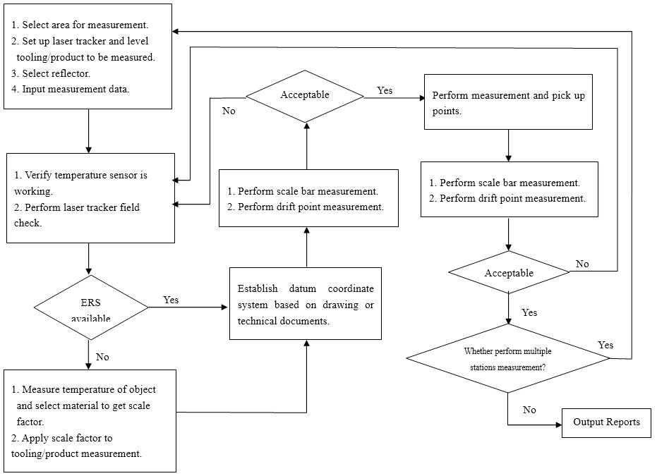
7 Record Control

7.1 Fill in and maintain relevant records according to GLC231008.
7.2 Production unit save measurement reports and will upload original measurement data files and other format measurement data files to the distribution area of the company for storage and backup per GLB14080302-04.

